

NOTRE DAME UNIVERSITY
BANGLADESH
CSE-3104 LAB Report-06

Course Title: Compiler Design Lab
Course Code: CSE-3104

Submitted by:
Name: Istiak Alam
ID: 0692230005101005
Batch: CSE-20
Submission Date: 24-11-24
Lab Task Topic: Compiler Problem Solving using Lex

Submitted to:
Khorshed Alam
Lecturer, NDUB
Problem:
Write a C Program to implement Recursive Decent Parser for Grammar:-
E->E+T|T T->TF|F* F->id.

Solution:

Code : –
//The Recursive Decent Parser is implemented Using C++
#include<string.h>
#include <iostream>
using namespace std;
int i,err;
char inp[10];
void E();
void E1();
void T();
void T1();
void F();
int main(){
i=0,err=0;
cout << "Enter String: ";
cin >> inp;
E();
if(strlen(inp)==i && err==0)
cout << "STRING ACCEPTED...!!\n" << endl;
else
cout << "STRING NOT ACCEPTED...!!\n" << endl;
}
void E(){
T();
E1();
}
void E1(){
if(inp[i]=='+'){
i++;
T();
E1();
}
}
void T(){
F();
T1();
}
void T1(){
if(inp[i]=='*'){
i++;
F();
T1();
}
}
void F(){
if(isalnum(inp[i]))
i++;
else if(inp[i]=='('){
i++;
E();
if(inp[i]==')')
i++;
else
err=1;
}
else
err=1;

}

Recursive Decent Parser Output:

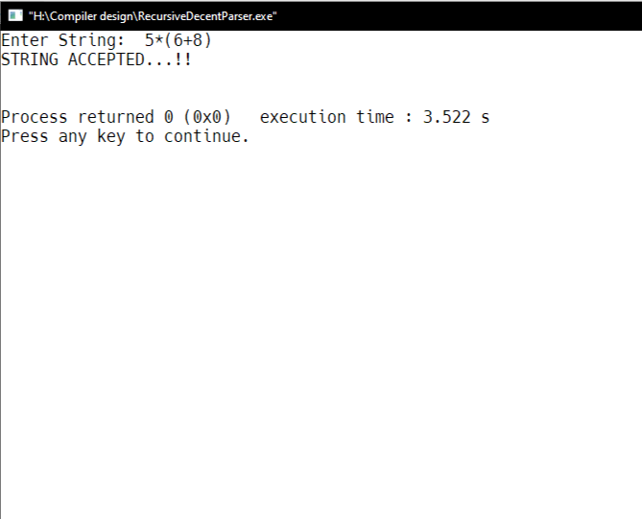

Output

